Quantity

🌟 Definition
# Source: AI Source: Provided by: [Data Path: Persons Table -> ID Column: 1, Name_En Column: Motasem Essam] -> From: [ChatGPT] on [5/30/2026]
Quantity is the division of pure mathematics that studies numbers, amounts, magnitudes, and numerical relationships.
It is concerned with understanding how quantities are represented, counted, measured, compared, and related to one another.
Historically, quantity is one of the oldest and most fundamental areas of mathematics.

🎯 Purpose
# Source: AI Source: Provided by: [Data Path: Persons Table -> ID Column: 1, Name_En Column: Motasem Essam] -> From: [ChatGPT] on [5/30/2026]
- To study numbers and numerical systems
- To understand numerical relationships
- To investigate properties of numbers
- To develop methods of counting and measurement
- To establish the foundations of arithmetic and number theory

📚 Main Branches of Quantity

1. Arithmetic
# Source: AI Source: Provided by: [Data Path: Persons Table -> ID Column: 1, Name_En Column: Motasem Essam] -> From: [ChatGPT] on [5/30/2026]
Studies basic operations on numbers.
Topics
- Addition
- Subtraction
- Multiplication
- Division
- Fractions
- Decimals
- Percentages
Example
$$15+10=25$$

2. Number Theory
# Source: AI Source: Provided by: [Data Path: Persons Table -> ID Column: 1, Name_En Column: Motasem Essam] -> From: [ChatGPT] on [5/30/2026]
Studies the properties and relationships of integers.
Topics
- Prime numbers
- Divisibility
- Factors and multiples
- Congruences
- Diophantine equations
Example Question
- Are there infinitely many prime numbers?

3. Numerical Systems
# Source: AI Source: Provided by: [Data Path: Persons Table -> ID Column: 1, Name_En Column: Motasem Essam] -> From: [ChatGPT] on [5/30/2026]
Studies ways of representing numbers.
Topics
- Natural numbers
- Integers
- Rational numbers
- Real numbers
- Complex numbers
Example
Natural numbers:
{1, 2, 3, 4, ...}

4. Measurement Theory
# Source: AI Source: Provided by: [Data Path: Persons Table -> ID Column: 1, Name_En Column: Motasem Essam] -> From: [ChatGPT] on [5/30/2026]
Studies quantities that can be measured.
Topics
- Length
- Area
- Volume
- Mass
- Time
Example
- Measuring the area of a field.

🧩 Main Mathematical Objects Studied
# Source: AI Source: Provided by: [Data Path: Persons Table -> ID Column: 1, Name_En Column: Motasem Essam] -> From: [ChatGPT] on [5/30/2026]
- Numbers
- Integers
- Fractions
- Real numbers
- Complex numbers
- Ratios
- Proportions
- Quantities
- Magnitudes

🔑 Fundamental Concepts
# Source: AI Source: Provided by: [Data Path: Persons Table -> ID Column: 1, Name_En Column: Motasem Essam] -> From: [ChatGPT] on [5/30/2026]
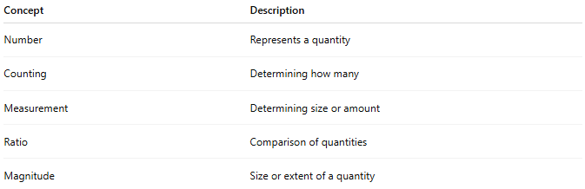
Concept | Description
Number | Represents a quantity
Counting | Determining how many
Measurement | Determining size or amount
Ratio | Comparison of quantities
Magnitude | Size or extent of a quantity

✏️ Example Questions
# Source: AI Source: Provided by: [Data Path: Persons Table -> ID Column: 1, Name_En Column: Motasem Essam] -> From: [ChatGPT] on [5/30/2026]
- What is a prime number?
- How many divisors does a number have?
- How can quantities be compared?
- What properties do integers possess?
- How are numbers classified?

🔗 Relationship to Other Divisions of Pure Mathematics
# Source: AI Source: Provided by: [Data Path: Persons Table -> ID Column: 1, Name_En Column: Motasem Essam] -> From: [ChatGPT] on [5/30/2026]
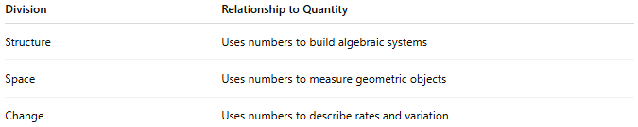
Division | Relationship to Quantity
Structure | Uses numbers to build algebraic systems
Space | Uses numbers to measure geometric objects
Change | Uses numbers to describe rates and variation

🧠 Simple Analogy
# Source: AI Source: Provided by: [Data Path: Persons Table -> ID Column: 1, Name_En Column: Motasem Essam] -> From: [ChatGPT] on [5/30/2026]
Quantity answers questions such as:
- How many?
- How much?
- How large?
- How small?
If mathematics were a language, Quantity would be the study of its numbers and numerical meaning.

🧭 Summary
# Source: AI Source: Provided by: [Data Path: Persons Table -> ID Column: 1, Name_En Column: Motasem Essam] -> From: [ChatGPT] on [5/30/2026]
Quantity is the division of pure mathematics that studies numbers, amounts, magnitudes, and numerical relationships. Its main areas include arithmetic, number theory, numerical systems, sand measurement, making it the foundation for understanding and working with quantities in mathematics.

